AREA 7 LIAISON COMMITTEE
Minutes Summer Meeting 02/08/21

- Apologies for Absence:
- Milton Keynes RC
- Cambridge & District RC

- Minutes of the Previous Meeting:
- Additional bank signatories, Friday all paperwork submitted and will have online access, can then add signatories; will need two to sign with Area 7 Chair and secretary to be added to signatory list.
- Gazeebo has been ordered and sorted.
- Previous minutes agreed.

- Matters Arising:

- Treasurers Report:

- There was some confusion with the accounts from the horse trials qualifier. Mark was sent spreadsheet, with ins and out for horse trials, however, only four items on the spreadsheet that tallies with bank statement. Others are different amounts.
- Kate will spend time adding up and seeing where differences are from with Bozeat RC and HHRC.
- HHRC paid to Bozeat for access to cash to pay Lloyd and ACE.
- Will all be corrected with evidence.
- Katy will present to Mark and Leslie to confirm.
- £10,194.79p currently in bank account with £73.92 owed to Bozeat still.
- A provisional £2602.53 profit was made at the horse trials.

A resolution was passed to remove Celia Wicher as an authorised signatory for the Area 7 bank account as she is no longer a committee member. Signed below.
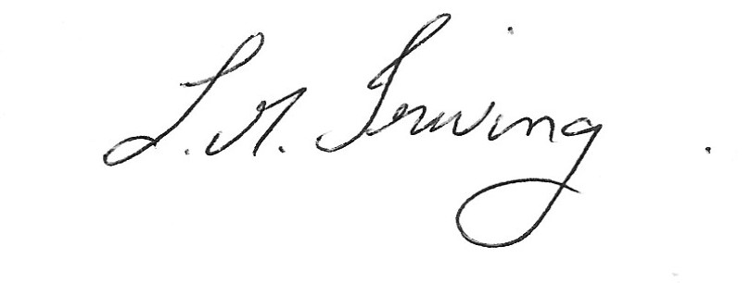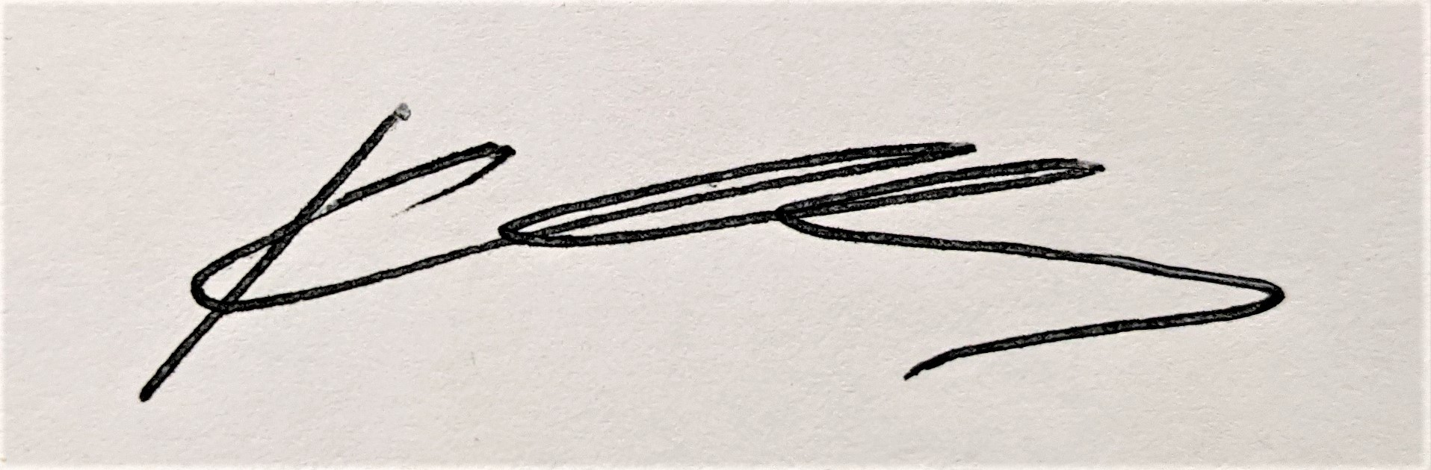

- Area Rep Report:
- Pure XC champs- head office not keen as hasn’t worked in the past.
- Lincoln championships will be in person.
- Hoof boots are still banned.
- Flu vacs will be random checks on the day and to be pre sent.
- Summer champs will not be on a surface in the short term.
- Virtual champs had 1254 test in 58 arena and 38 judges. Biggest virtual comp in the past year. BRC are planning on running a virtual comp again at XMAS with an under 10 section/ lead rein.
- Arena eventing timetable changing next year, going to run over 3 days to fit more competitors in.
- Arena challenge going to be re-named combined challenge as name is too similar to arena eventing.
- Pairs dressage at Lincoln champs will be direct entry only.
- There will be an intro and prelim dressage champs alongside DTM from 2022, for teams and individuals. With an intro pairs class, split snr/jnr. There will be a qualifier for this.
- There will be a tweak to eligibility taking away top six for 90 xc and 80 sj will be 5 BE points but no novice, downgrade will become 10BE points each year. CT 75/85 remove BS and BD points but not BE.

- Past Events:
- Horse trials- David Clarke congratulated the running of this event as it is not an easy job to do. Got through the day without any major hiccups. KB amazing for all the clubs, everyone went above and beyond to run it all. Online scoring worked really well, with ACE on-hand to help sort out any connection issues. Clare- noted that the XC warmup had a long rope for the entrance. This was too long with spectators too close to SJ ring. Needed an electric fence post. Wasn’t sure who the organiser was to ask for things. Rider feedback was perhaps to have a XC fence in the warmup. Dog training next to the warm ups and dressage ring was a bit of an issue. Bit more parking guidance as some bad parking.
- Look at places such as Horse Heath as still within area for next year? Sarah said she will talk to Lloyd about possibly at Offchurch, but might be too far for members.

- Show Jumping- Well done Kelley, good job. Parking was always going to be tight. Topper broke so grass was long. Day ran well and course was nice. Surface was a bonus. Some competitors found it a little bit frustrating to not know it was going to be on a surface until last minute. That had been discussed dependent on numbers. Noted that there was no spread in the warm up, unfortunately there was not enough safety cups. Lots of help with course building and help on the day. Asked teams to fill spots and they did. Online scoring good. Tight warm up

- DTM- very hot! Relocation and change of date, only one available at Moulton College unfortunately. Had a good day, seemed to all run well.

- Future Events:
- 9th October Dressage at Bury Farm,
- 19th September Arena Eventing at Codham Park.
- 20th November Show Jumping at Arena UK.
- Keysoe International pulled out when paying deposit for arena eventing. Back up venue is closed unfortunately.
- Combined challenge update, despite date advertised and asking for confirmation, even with a site visit and discussion, was waiting for Keysoe International to confirm a price. Wouldn’t commit so have had to cancel. Have looked at other venues, Moulton had a small XC, but would need to hire in portables, but only on 19th September. Instead was decided only option was to run alongside the HHRC show on the 10th October. Keysoe willing to support in any capacity. Know it is a date clash but no other choice really.

- Training:will lose training money I not run this year. DC needs volunteer to help run a junior training? Maybe run alongside Aspley guise camp running at aston. Will subsidise. DC send to sarah details of what they need. Junior are very keen. About 360 for all 3 days and 280 for 2 days. Barry also willing to run a day camp at his yard, can put together a day. DC to discuss and get back.

- AOB:
- KS- asking for area radios to be fixed/maintained. Maybe asking ACE to help fix? KS will look into it.
- Kit- to bring up to BRC about vax database, where they can upload the passports themselves. Has been discussed before but does not seem to have gone anywhere yet.
- Clare liked the option of choosing helpers, rather then it being given.
- Kit- at the HT when co-ordinating helpers some are members of multiple clubs. How do we know if members are helping for what club? Will have to rely on honesty.
- DC- North Mymms RC have applied to be in Area 8 and this has been approved. Will be in effect from 1st April. MI will need to move committee.
- KB- Rebecca has asked to do an Area 7 110 team from head office for the Lincoln champs, 1 rider from MKEC has declined so now a team of 3, 2 HHRC and one RFRC. Can substitute a fourth rider as long as someone signs off as capable of 110cm if they didn’t do the qualifier. If the fourth slot can’t be filled then the Area will cover the cost of that entry.

- Date of Next Meeting: October 4th 8pm.

